Ejecución del software

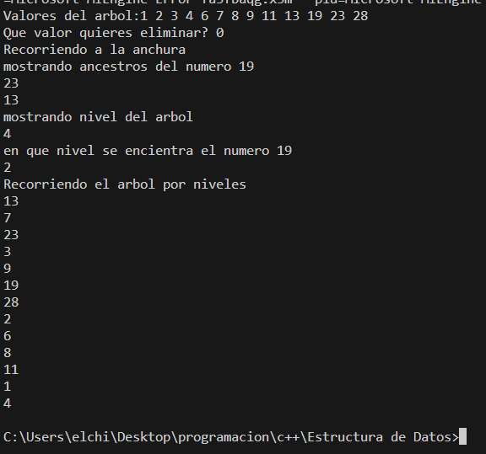

Complejidad:

compareNodeValues:

Complexity: O(1)

addValue (Insertion):

Average Case Complexity: O(log n)

Worst Case Complexity: O(n)

findValue (Search):

Average Case Complexity: O(log n)

Worst Case Complexity: O(n)

removeValue (Deletion):

Average Case Complexity: O(log n)

Worst Case Complexity: O(n)

count:

Complexity: O(n)

BFS (Breadth-First Search):

Complexity: O(n)

PreOrder Traversal:

Complexity: O(n)

PostOrder Traversal:

Complexity: O(n)

showHeight:

Complexity: O(n)

ancestors:

Complexity: O(n)

whatLevelAmI:

Complexity: O(n)